# Lesson 2 – Symbolization in a GIS

## GENERAL INFORMATION ON SYMBOLIZATION

At its simplest level of representation, spatial data exists as points, lines, areas, or rasters. But representing these features, combined with their attributes, often means encoding something more complex than just geographic location. Symbolization is the process of encoding something with meaning in order to represent something else. Effective symbol design requires that the relationship between a symbol and the information that a symbol represents (the referent) to be clear and easily interpreted. Cartographers developed the visual variable system, a graphic vocabulary, to express these symbol-referent relationships on maps. The following figure shows a range of ways (not a complete list) you can modify feature symbolization to give it different meaning.

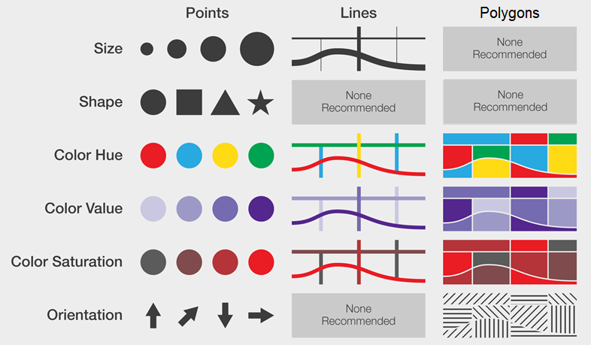

## UNIFORM SYMBOLIZATION

The term for a uniform symbolization of a layer in ArcGIS Pro is *Single Symbolization*. Single symbol symbology applies the same symbol to all features in a layer.

* The public transport points are to be symbolized in a meaningful way.

(Please continue with the project you created in last exercise, because some operations rely on the results of last exercise.)

### Symbolizing Bus Stops

Workflow_icon

1. Add the *bus\_stops* layer from the *Data Students.gdb* geodatabase.
2. Highlight the *bus\_stops* layer by clicking its title in the *Contents* pane.
3. On the *Feature Layer* tab in the *Drawing* group, CLICK the *Symbology* button  to choose how to symbolize the layer. The **Symbology** pane of the layer will open on the right.
4. DOUBLE-CLICK on the point symbol next to *Symbol.* The **Format Point Symbol** pane becomes active.
5. CLICK on the *Gallery* tab and TYPE a search word into the search text field to find an appropriate symbol for the bus stops.

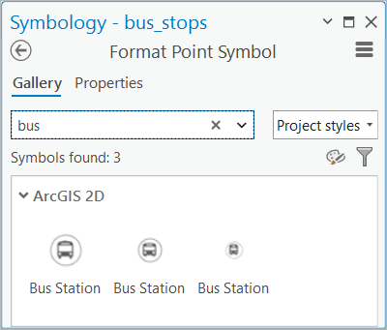

1. CLICK on a symbol. It should immediately change the layer´s appearance in the Map view.
2. Go to *Properties* on the **Format Point Symbol** menu and expand *Appearance* by CLICKING on the dropdown arrow.
3. Modify the symbols colour by changing the fill colour with *Color* and adapt the *Size* if required.
4. CLICK *Apply* to activate the made changes.
5. You can CLICK the *back* button to return to the *Primary Symbology* pane.

* A symbol can consist of multiple symbol layers. You can access all of the properties of each symbol layer that makes up the point symbol. You have to CLICK on the desired symbol layer to modify its properties.

### Symbolizing Tram Stops and Underground Stations

Changing the basic properties of a symbol is a quick way to make common changes without having to navigate within the entire symbol structure. The basic properties differ depending on symbol type. To make complex edits, with individual layers of a symbol, you must work with only one symbol at a time.

* The task is to symbolize the tram stops and underground stations using the official logos of the MVG as external vector graphic files. The external logo files can be found on Moodle under *Symbols.*

1. Go to the *Format Point Symbol* pane of the *tram\_stops* layer. Another way of opening the *Format Point Symbol* pane is by DOUBLE-CLICKING on the feature class´s point symbol on the *Contents* pane.

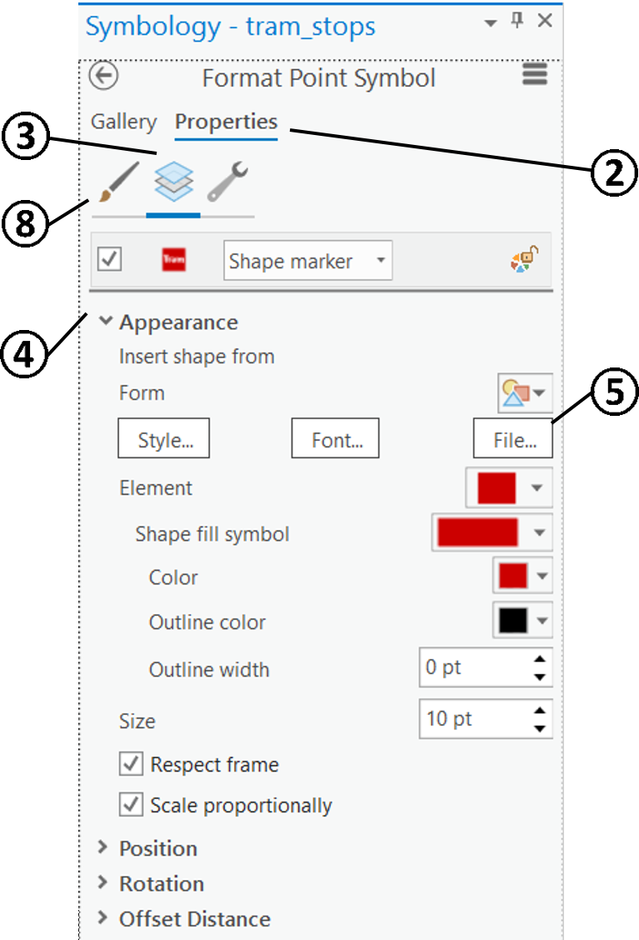

* CLICK on the *Properties* tab.
* CLICK on the *Layers* tab .
* CLICK to expand the *Appearance* dropdown menu.
* CLICK to open the **File…** dialog box.

1. Browse to the Folder *Symbols* (which You downloaded from Moodle) and CLICK on the *Tram\_logo.svg* file. CLICK *OK* to open the vector graphics file.
2. CLICK *Apply* on the **Browse vector file** dialog box to inspect the changes in the map view.

* CLICK on *Symbol*  to adapt the symbol *Size* if required.
* Anytime You wish to view all features of a certain layer you can zoom to the extent of this specific layer by RIGHT-CLICKING on the layer in the *Contents* pane and CLICKING *Zoom To Layer* .
* Symbolize the Underground stations using the *UBahn\_logo.svg* file.

## QUALITATIVE SYMBOLIZATION

For qualitative symbolization unique values show categories of values. Examples include habitat types, planning zones, voting preferences, and soil classifications. Unique value symbology can be based on one or more attribute fields in the dataset.

### Symbolizing Polygons

* Symbolize the museums in a unique colour by symbolizing by the *tourism* field values.

1. Highlight the *buildings* layer by clicking its title in the *Contents* pane.
2. On the *Feature Layer* tab in the *Drawing* group, CLICK the *Symbology* button  to choose how to symbolize the layer. The **Symbology** pane of the layer will open on the right.
3. CLICK the dropdown arrow to CLICK on *Unique Values*.

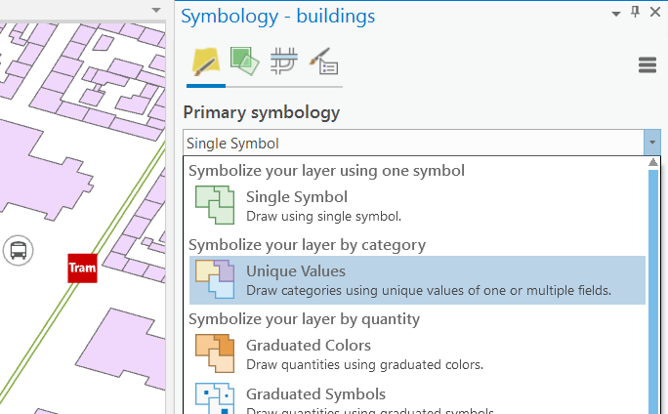

1. In the **Symbology** pane, on the **Primary symbology tab** Primary symbology, in the *Field 1* menu, choose the field *tourism* on which is to be symbolized. The buildings should be coloured depending on the attribute classes of *tourism*. Make sure the museums are visually distinguishable from other building polygons.
2. If you like, alter the *Color scheme* or change the appearance of a class by CLICKING on the *Format symbol* on the listed *Classes* subsection.

* Symbolize the TUM in a unique colour without losing the museums colour coding. Symbolize other buildings in a uniform way. (In Lesson 1 the value *technical university* or *TUM* was written into the field *amenity* of the *buildings layer*.)
* In the **Symbology** pane, on the **Primary symbology tab** Primary symbology, CLICK *Add field* under the *Field 1* menu.
* On the *Field 2 dropdown* menu, choose the field *amenity.* As there are lots of different OSM values for the geotag *amenity*, you receive a category coded symbolisation featuring many classes.

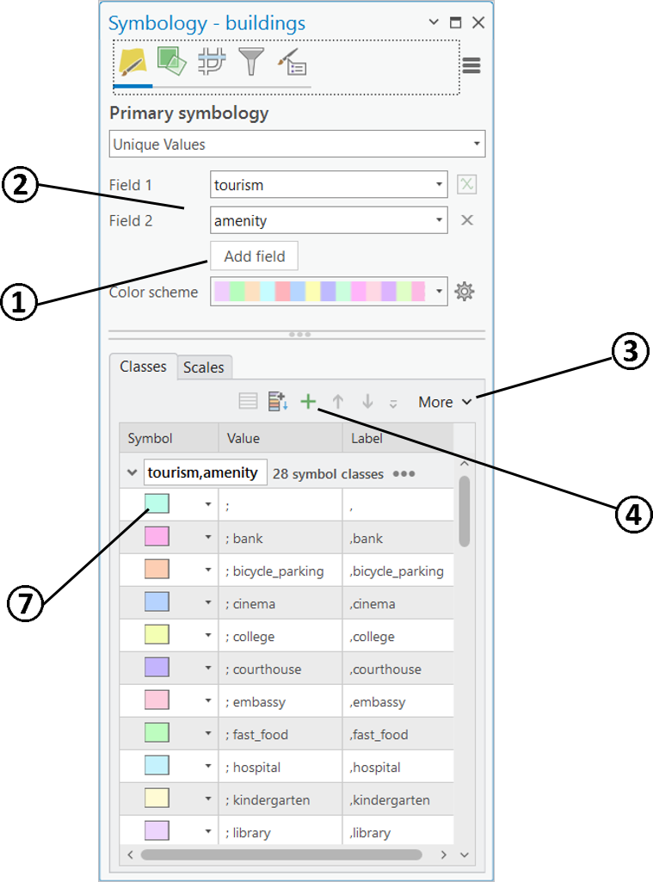

* Remove all classes to add only the required ones. CLICK on the *More* dropdown arrow to SELECT *Remove all.*
* CLICK on the *Add unlisted values* button .

1. In the **Select values to add** pane, select the *technical university* or *TUM* class, and while HOLDING the Crtl button, select the *museum* class and the “*blank”* class (all the classes other than the selected classes, in this case, all the classes other than *museum* class and *technical university* class), too.
2. CLICK *OK* to confirm the selection.

* Change the appearance of the TUM buildings and the museums. Please assign visually distinguishable and associative colours by CLICKING on the *Format symbol* (see the above screenshot) on the listed *Classes* subsection.

## QUANTITATIVE SYMBOLIZATION

### Graduated Symbology

**Quantitative** symbolization allows an estimation of the actual numerical difference between symbols. Similar to qualitative symbolization, graduated value symbology can be based on one or more attribute fields in the dataset, or you can write an Arcade expression to generate values on which to symbolize.

* Symbolize the building heights by using a standard story height of 3.5 m. Note that the building-level attribute data is incomplete. There are many no-data values to be considered. Use an Arcade expression to calculate the story height.
* Arcade is an expression language that can be used across the ArcGIS Platform. It is designed to write simple scripts in a syntax similar to JavaScript.

1. Go to the *Primary symbology* tab of the *buildings* layer.
2. CLICK the dropdown arrow to CLICK this time the *Graduated Colors* option.
3. CLICK the *Expression* builder , next to *Field*, to open its dialog box.
4. On the *Expression* builder dialog box, in the *Expression* box, TYPE in $feature.level\_num\*3.5 to use a standard story height of 3.5 m for estimating the building heights
5. CLICK the *Color scheme* dropdown arrow to select a monochromatic colour ramp form light to dark. View the intermediate result.

### Information on Data Classification

When you classify your data, you can use one of many standard classification methods provided in ArcGIS Pro, or you can manually define your own custom class ranges. Classification methods are used for classifying numerical fields for graduated symbology.

**Manual interval**

Use *manual interval* Manual Class to define your own classes, to manually add class breaks and to set class ranges that are appropriate for the data. Alternatively, you can start with one of the standard classifications and make adjustments as needed.

**Defined interval**

Use *defined interval* Defined Interval to specify an interval size used to define a series of classes with the same value range. For example, each interval will span 75 units. The number of classes based on the interval size and the range of all field values is determined automatically.

**Equal interval**

Use *equal interval* Equal Interval to divide the range of attribute values into equal-sized subranges. This allows you to specify the number of intervals, and the class breaks based on the value range are automatically determined. For example, if you specify three classes for a field whose values range from 0 to 300, three classes with ranges of 0–100, 101–200, and 201–300 are created.

**Quantile**

In a *quantile classification* Quantile Class each class contains an equal number of features. A quantile classification is well suited to linearly distributed data. Quantile assigns the same number of data values to each class. There are no empty classes or classes with too few or too many values.

**Natural breaks (Jenks)**

With *natural breaks* classification (*Jenks*) Natural Breaks Jenks, classes are based on natural groupings inherent in the data. Class breaks are identified that best group similar values and that maximize the differences between classes. The features are divided into classes whose boundaries are set where there are relatively big differences in the data values.

**Geometrical interval**

The *geometrical interval* classification scheme Geometric Interval creates class breaks based on class intervals that have a geometric series. The geometric coefficient in this classifier can change once (to its inverse) to optimize the class ranges. The algorithm creates geometric intervals by minimizing the sum of squares of the number of elements in each class. This ensures that each class range has approximately the same number of values in each class and that the change between intervals is fairly consistent.

**Standard deviation**

The *standard deviation* classification method Standard Deviation shows you how much a feature's attribute value varies from the mean. The mean and standard deviation are calculated automatically. Class breaks are created with equal value ranges that are a proportion of the standard deviation—usually at intervals of one, one-half, one-third, or one-fourth standard deviations using mean values and the standard deviations from the mean.

### Classifying Data

* Classify and symbolize the building heights into reasonable classes. The no data values must be defined in a separate class.
* Go to the *Primary symbology* tab of the *buildings* layer. The *Graduated Colors* option should be chosen.
* CLICK on the *Histogram* tab of the lower section to get an overview of the variable distribution.
* CLICK on *More* to activate *Show statistics*. Some basic statistics are showed at the bottom of the Primary Symbology pane. Max. value should be *31.5*.
* Go back to the class interval view by CLICKING the *Classes* Tab.
* CLICK on the *Method* dropdown arrow to try out different classification methods.
* CHOOSE a reasonable number of classes with the corresponding dropdown arrow.
* To define the no data values in a separate class, DOUBLE-CLICK the *Upper value* of the top listed class. TYPE 0 and press ENTER. The no data values (those that feature a zero as building height) will be exclusively sorted in a separate class. You can also change the interval of other classes by changing their *Upper value*.
* The no data value class should not be visualized in the same colour scheme as the other classes. Otherwise it makes the impression that these are the lowest values (but in fact there are unknown). CLICK on the Symbol of the no data class. Assign a neutral light grey colour to the no data class in the *Format Polygon Symbol* pane.

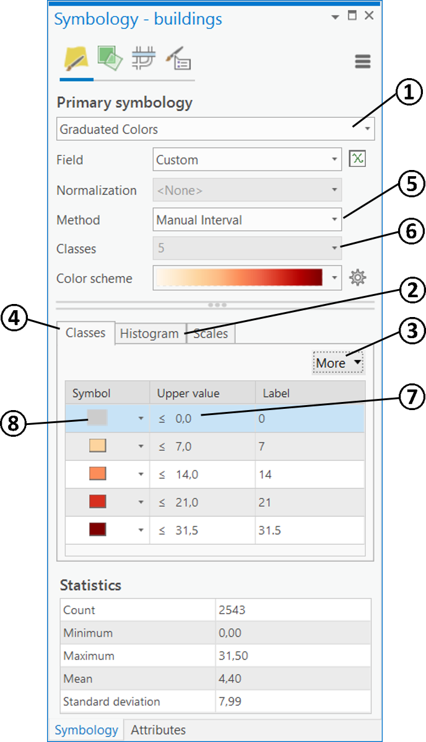

### Proportional Symbology

Proportional symbology is used to show relative differences in quantities among features. Proportional symbology is similar to graduated symbols symbology in that both draw symbols sized relative to the magnitude of a feature attribute. But where graduated symbols distribute features into distinct classes, proportional symbols represent quantitative values as a series of unclassed symbols, sized according to each specific value.

* Symbolize the roads as proportional symbols. Their line width should indicate the allowed maximum speed.

1. Go to the *Primary symbology* tab of the *roads* layer.
2. CLICK the *Proportional Symbols* option.
3. CLICK on the dropdown arrow of *Field* and CHOOSE the field *speed\_num*. (this field name was edited in lesson 1)
4. Leave the *Normalization* option on *<None>* and the *Unit* option on *<Unknown>.*

* The *Normalization* menu is chosen to present ratios of a data value.
* The *Unit* option can represent the data values as actual measures on the map. I.e. setting the Meters to Meters would symbolize streets with a 50 kph speed limit at a 50 m width.

1. Here, we will use a relative proportional symbol. Set the *Minimum size* to zero in order to exclude the no data values from vision. CHECK the *Maximum size* and set an appropriate value for the *Maximum size.*

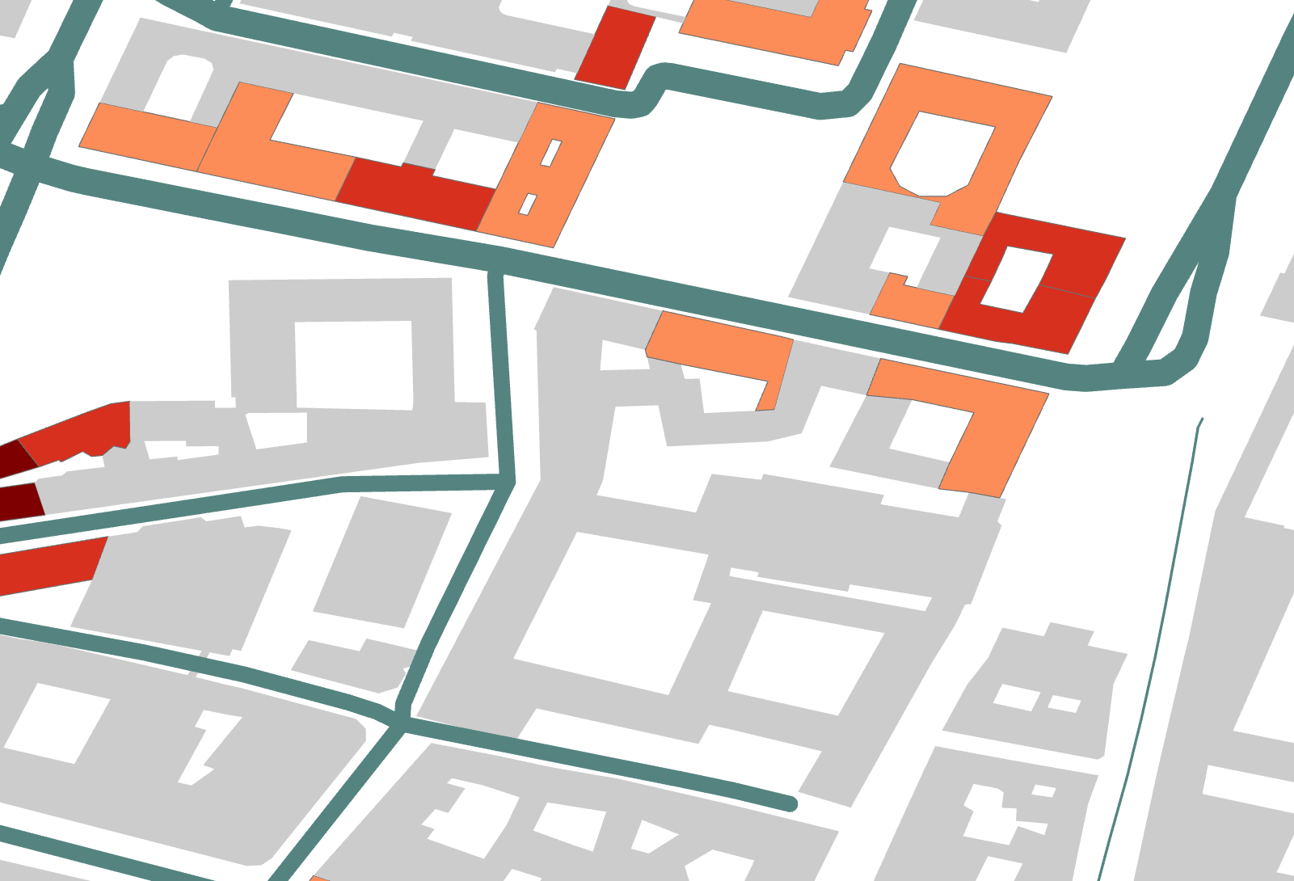

## SYMBOLIZING CASED LINE FEATURES

Line symbols typically contain one or more stroke symbol layers. Cased line symbols are accomplished by using at least a two-layer line symbol. The first, bottommost, layer is a wide line, typically black. The second is a slightly narrower line that is either coloured or is blank white.

* Symbolize the car traffic roads as cased roads and all other road lines as uniform simple lines.

### Creating a Multi-Layer Symbolization

1. Go to the *Primary symbology* tab of the *roads* layer.
2. CLICK the *Unique Values* option.
3. Choose this time *type of road* as *Field 1*. (this field name was edited in lesson 1)
4. Remove all classes  and *Add unlisted values*  in the same way as in 2.3.
5. In the **Select values to add** pane, select the classes *residential, secondary*, *secondary\_link*, and *tertiary*.
6. CLICK *OK* to confirm the selection.
7. Change the appearance of a selected road class by CLICKING on the *Format Symbol*. Choose a cased road example from the *Gallery*. You can modify the appearance by CLICKING on *Properties* and then on the *Layers* tab .
8. Save your symbol style by CLICKING on the hamburger icon and CLICKING *Save Symbol to Style.* Your style will now appear at the top of the *Gallery*.
9. Assign the same symbolization to the other selected road classes by choosing the previous style of the *Gallery.*
10. Choose a thin line symbol in a light grey colour for *<all other values>.* This puts the minor paths visually more in the background.

* If the class *<all other values>* is not shown, CLICK on *More* to open the dropdown menu, and CLICK on *Show all other values*.

### Joining and Merging Line Features

Use symbol layer drawing to override the default drawing order of symbols on maps. When symbols have more than one symbol layer (such as a cased road symbol), symbol layer drawing can also control how those individual symbol layers are ordered across symbol classes. That means, that cased roads can graphically join and merge at intersections.

|  |  |
| --- | --- |
| Two symbol classes (cased roads) are both set to *No Join*. Notice that each line segment is drawn independently. This is the same draw behaviour as when symbol layer drawing is not enabled. | Two symbol classes, both set to No Join |
| Two symbol classes are both set to *Join*. Notice that the interior road symbology is combined across symbol classes, but line casings separate the two classes. | Two symbol classes, both set to Join |
| Two symbol classes are both set to Join and Merge. Notice that the interior road symbology is combined across symbol classes, with the casing symbology drawing beneath all interiors. When Join and Merge is set on a symbol class, the symbology of that layer is merged with the symbology of the symbol class immediately above it in the *Drawing Order* list. | Two symbol classes set to Join and Merge |

* Join and Merge the graphic lines of the cased roads to show connectivity across individual road segments.

1. Look at the previously designed cased roads. The line segments are drawn independently. Therefore, these make an isolated appearance.

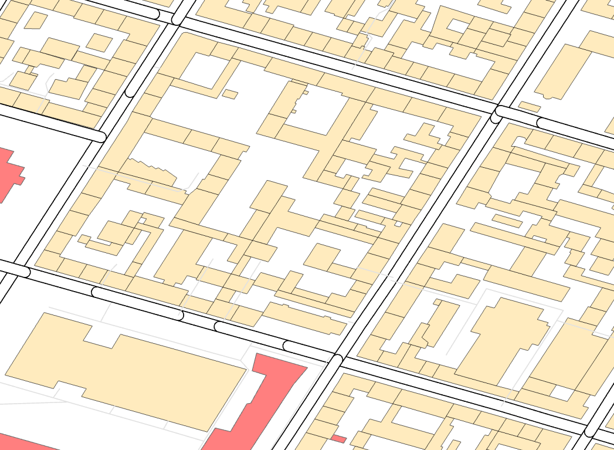

1. Open the *Symbology* pane of the *roads* feature class.

* In the **Symbology** pane, on the *Symbol layer drawing* tab .
* Turn on *Enable symbol layer drawing* by using the toggle switch.

1. Check the road features on the map. The *Basic* symbol layer drawing solves most of the joining problems. Though, the merging of different category classes is not solved well yet. There are still many graphic conflicts.

* CLICK on the *Advanced* tab,
* Expand a numeric group and DRAG symbol layers from one group to another to change their drawing order. To create a new group, RIGHT-CLICK a symbol class and CLICK *Move to a new group*. The symbol layer is added to a new numeric group at the bottom of the Drawing Order list.
* Optionally, CLICK *Reset* to revert the state of the layer (or group layer) to the default symbol layer drawing state.
* CLICK and DRAG the top Layers (*Layer 2*) in one group above a group with the bottom layers (*Layer 1*).

1. Check the road features on the map. The joining and merging of the streets should be correct.

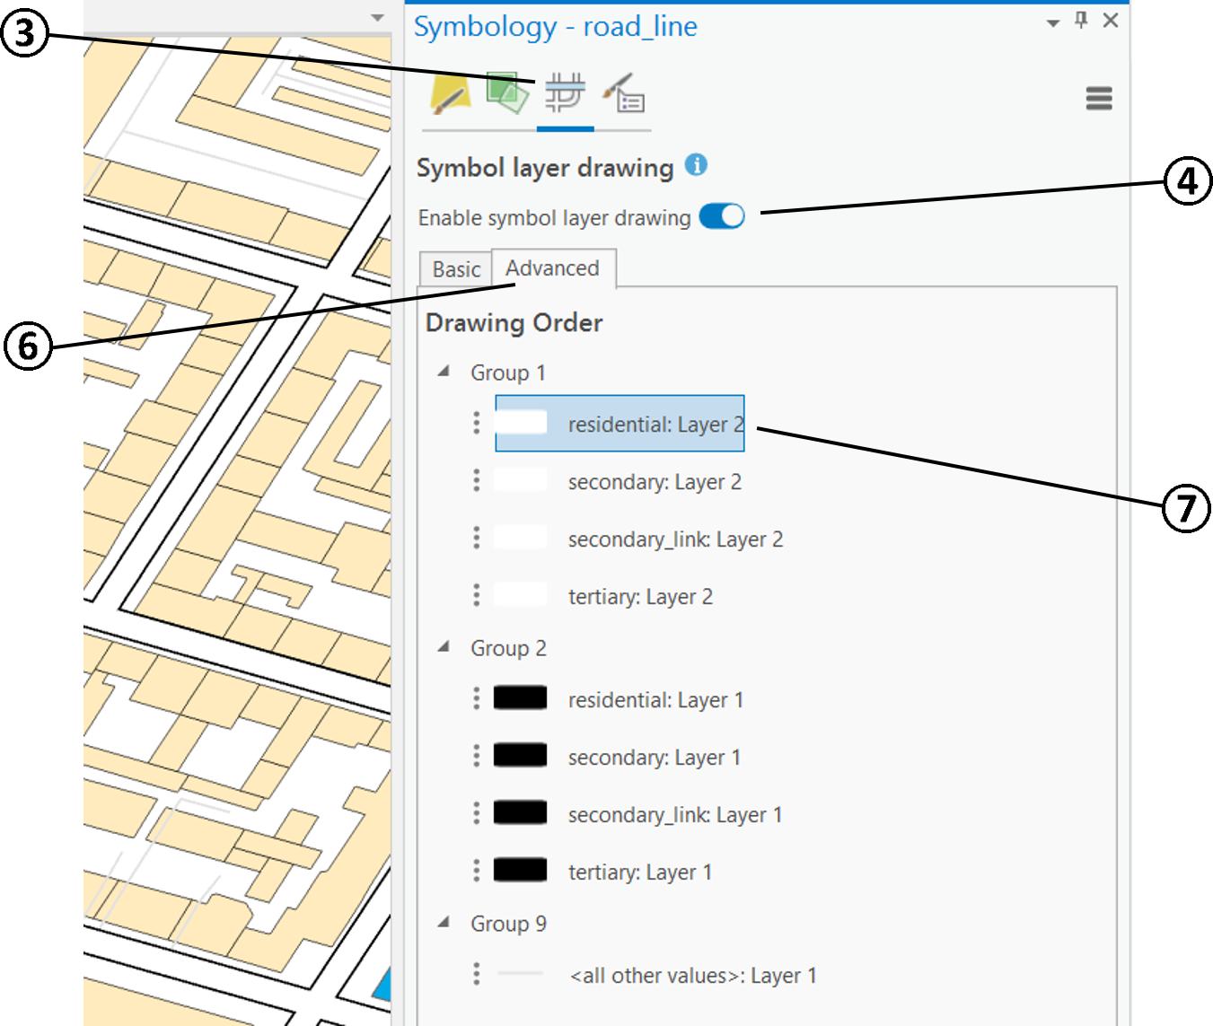

* If you choose later to disable symbol layer drawing, all of the settings are maintained.

## SCALE-BASED SYMBOLISATION

### Scale-Based Symbol Classes

When a layer is symbolized with either unique value or graduated colours symbology, you can specify the visible scale range for each symbol class. This is an effective strategy to limit the amount of detailed data at smaller scales without having to make multiple versions of the layer, each with a unique definition query. Scale-based symbol classes limit the features that are shown at each scale.

* Apply scale based symbolization to the *roads* layer. The four car traffic road categories are to be visible between 1:10,000 and larger. The visible scaling range for other minor roads is to be 1:5,000 and larger.

1. Go to the Symbology pane of the layer *roads*.
2. On the Primary symbology tab Primary symbology, CLICK the *Scales* tab in the lower section.
3. On the *Scales* tab, adjust the scale sliders for each symbol class as following.

* The stops on the sliders are derived from the map scales. The slider extends across the complete scale range, from an infinitely small scale (zoomed very far out) on the leftmost end of the slider, to a large scale of zero (zoomed very far in) at the rightmost end of the slider. The darker part of the slider shows the scale range of the layer. The features of a symbol class only draw at scales that are within both the scale range of the layer and the scale range of the corresponding symbol class.

1. Adjust the scale sliders by DRAGING the stops. The four car traffic road categories are to be visible between 1:10,000 and larger (1:1 or *None*). The visible scaling range for other minor roads is to be 1:5,000 and larger. (See following figure.)

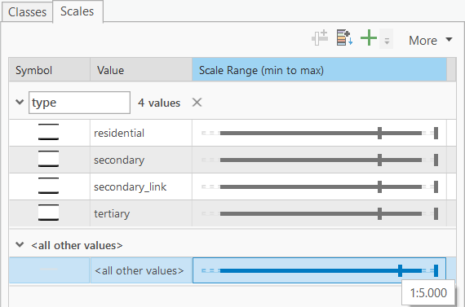

1. Try zooming in and out of the map and see the changes of the visible scale range for the layer *roads*. You can follow the current map scale on the bottom left of the *Map View*.

* When a layer has scale-based symbol classes, the legend shown in the *Contents* pane for the layer dynamically updates as you zoom in and out of the map so that only those symbol classes that are defined for the current scale are shown.

### Scale-Based Symbol Sizing

The size of symbols can be adjusted dynamically across their visible scale range to reduce visual density at smaller scales while retaining an appropriate relative size at larger scales. Typically, these differences in symbol size are subtle across the visible scale range. You want to maintain a symbol size appropriate for the feature density at each scale without introducing noticeable increases in size.

* Apply scale based symbol sizing to the public transport points.

1. Go to the Symbology pane Symbology of the layer *tram\_stops*.
2. CLICK the symbol to open the *Format Symbol pane*. (Alternatively, you can CLICK a symbol in the Contents pane to open the Format Symbol pane directly.)

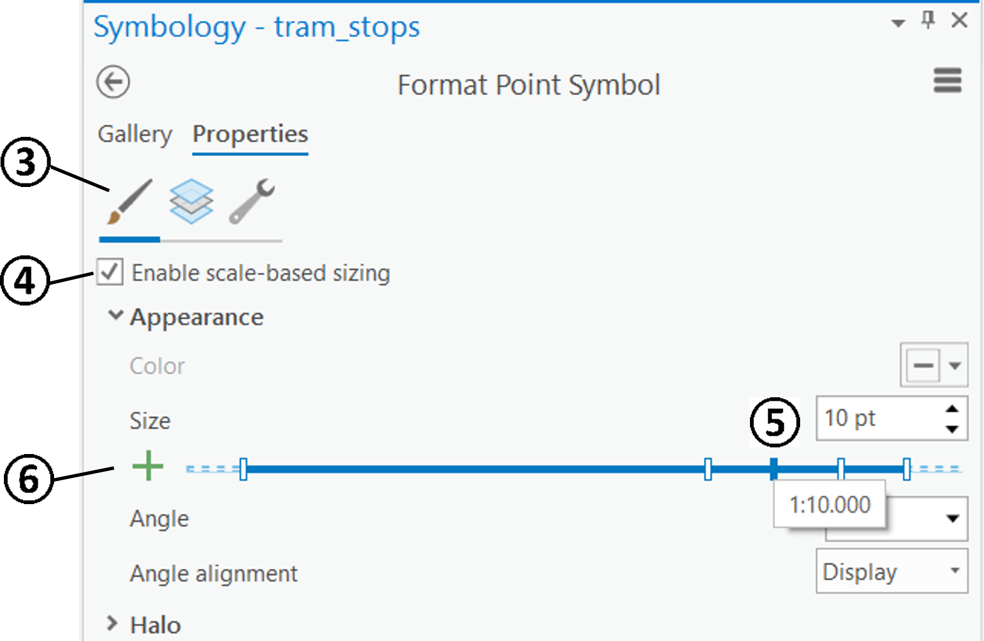

* Go to the *Symbol* tab Symbol on the *Properties* tab.
* CHECK *Enable scale-based sizing*. A slider appears below the *Size* property.
* A slider appears below the *Size* property for point symbols, the Line width property for line symbols, and the Outline width property for polygon symbols. The stops on the slider are derived from the map scales. The slider extends across the complete scale range, from an infinitely small scale (zoomed far out) on the left extreme of the slider, to a large scale of zero (zoomed far in) at the right extreme of the slider. The dark part of the slider shows the visible scale range of the symbol class or layer. (If the visible scale range is not constrained to specific scales for the corresponding feature class, the entire slider is dark.)
* CLICK a scale stop and define the symbol size at that scale in the *Size* property box.
* CLICK the *Add size stop* buttonAdd to add new stops based on the defined map scales, or click along the slider. You can CLICK and DRAG stops to define the size at a different scale. The point symbol size varies linearly in size between stops. Recommended values for the tram symbol are the following:

|  |  |
| --- | --- |
| Scale | Size |
| 1:1,000 | 50 pt |
| 1:5,000 | 18 pt |
| 1:10,000 | 10 pt |
| 1:24,000 | 5 pt |
| 1:100,000,000 | 1 pt |

1. To make a conflict free blending of the symbol layers the default size value has to be the same as the largest on used in the scale-based sizing. CLICK onto the *Layers* tab  and define the *Size* to *50 pt*.
2. CLICK *Apply* to execute the scale-based sizing rules and to view the effect on the Map.

* Apply scale based symbol sizing to the bus stops and the underground stations. You can use similar size values as for the tram stop symbols.

## APPLYING TRANSPARENCY

You can set transparency universally on a layer, or you can vary transparency by an attribute like a further visual variable. Varying the transparency of symbols is a way to blend in overlapping symbols or a way to indicate variations in magnitude of an attribute. Here we use universal transparency only.

* Adjust the transparency of the buildings, so that the orthophoto information underneath blends in with the building polygons.

1. Toggle on the visibility of the *orthophoto.tif* raster file.
2. Select the *buildings* layer in the *Contents* pane.
3. Try out the swipe tool to reveal hidden content occluded by a chosen layer. On the *Feature Layer* tab, in the *Effects* group, CLICK *on the Transparency* Transparency *drop-down arrow* to open a swipe tool. CLICK and DRAG to use this tool.
4. Adjust the *Transparency* slider Transparency or type a transparency percentage, so that You blend the orthophoto together with the *buildings* layer.

* When You select a raster layer in the Contents pane, you find the Transparency tool under the *Raster Layer* tab.

## COMBING ACQUIRED SKILLS

### Symbolizing Dashed Strokes

* Symbolize the underground lines , , , München U4.svg, 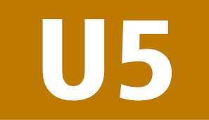 and  with the layer *underground\_lines* by line number in corresponding colours. (The layer *underground\_lines* has been created in Lesson 1.)

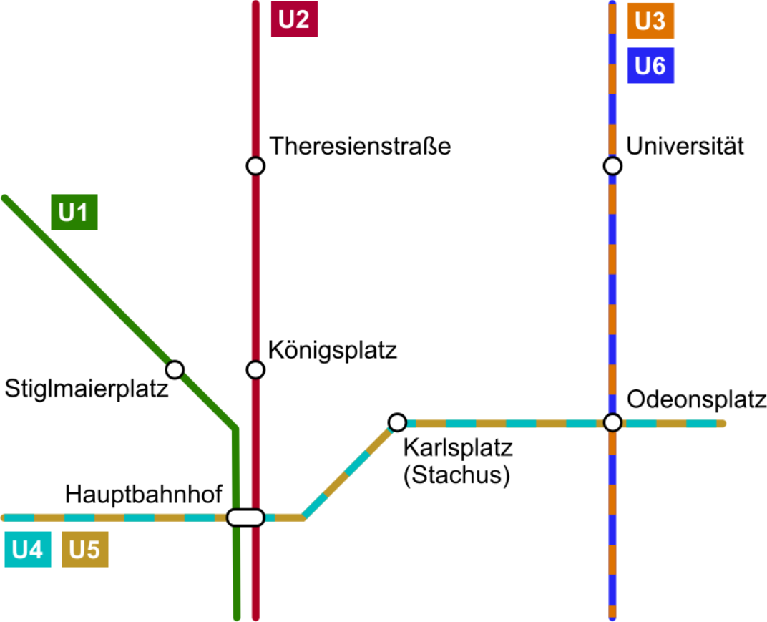

1. Create a new field for the attribute table of the layer *underground\_lines* (data type: *text*) for adding line number information (see lesson 1 for workflow).
2. Select ALL the underground polylines of one underground line. Deselecting all other layers makes interactive selecting  easier. (Info to selection see in Lesson 1). HOLD DOWN the SHIFT-KEY to add to a current selection.

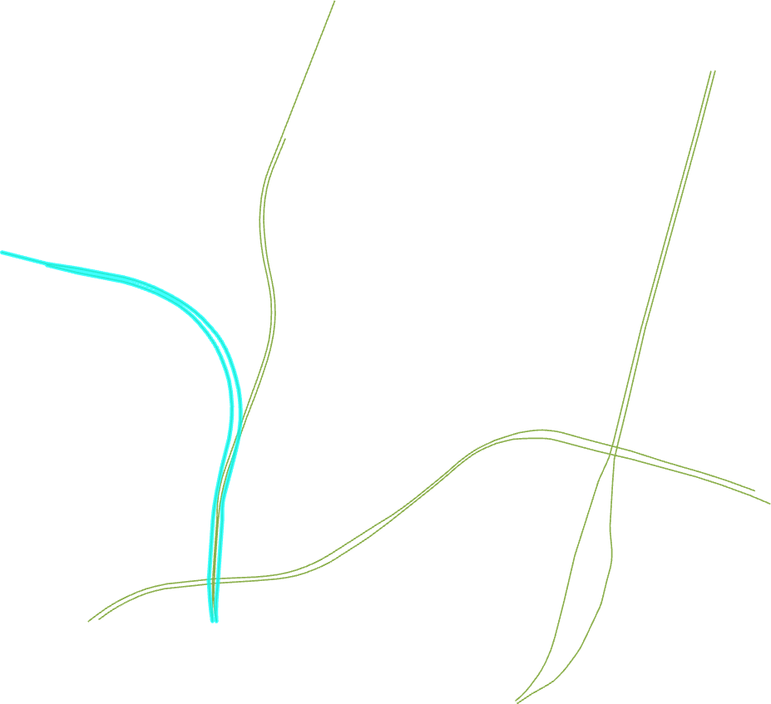

1. After the selection of one line, write the number (or numbers) into their attribute records (see lesson 1, use *Calculate Field*).

* Remember to use quotation marks when writing non-numbers.

1. Repeat this for the other underground lines.
2. Symbolize the underground lines by category using colour-coded underground lines. Use a solid stroke for the U1 and U2 lines.

* Line Caps:

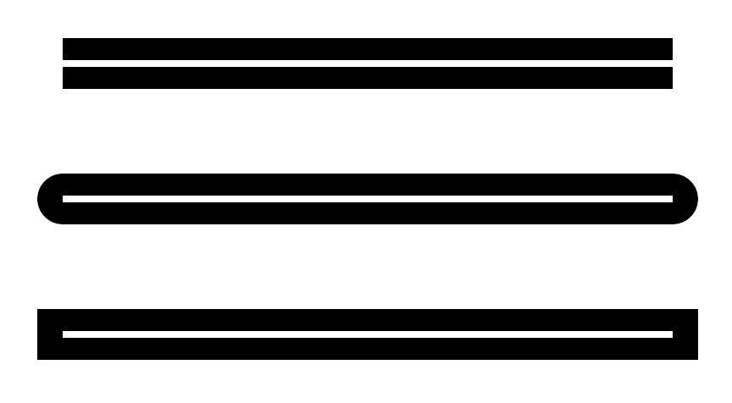

Butt:

Round:

Square

Line Joins:

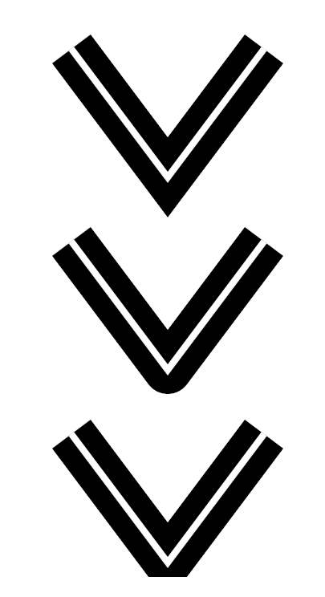

Miter:

Round:

Bevel:

1. Create a multi-layered symbology (see 2.5.1) for the shared U3/U6 line (on the Ludwigstraße) as well as U4/U5 line. Hereby, make a solid stroke underneath and a dashed (hachured) stroke on top to create a bicolour line. The dash effect can be set under *Format Line Symbology > Dash effect*.
2. Choose a dash from the *Dash type* pull-down gallery, and adjust the *Dash template* values as necessary. Each dash value in the template represents the next segment of the dash; for example, a dash template of '7 3' would return a 7 point stroke followed by a 3 point gap, followed by another 7 point stroke and 3 point gap, and so on.

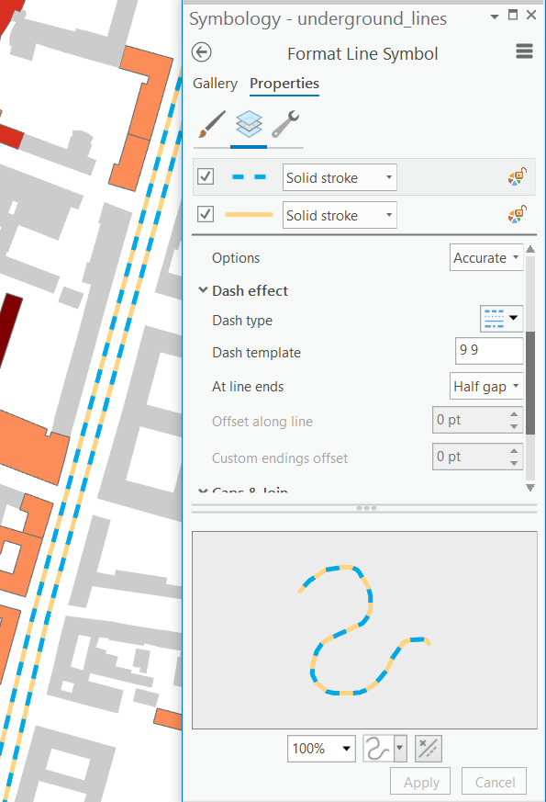

1. Sort the lines under the buildings in the *Contents* pane to indicate the underground alignment.

Contents

[Lesson 2 – Symbolization in a GIS 1](#_Toc180999647)

[2.1 GENERAL INFORMATION ON SYMBOLIZATION 1](#_Toc180999648)

[2.2 UNIFORM SYMBOLIZATION 1](#_Toc180999649)

[2.2.1 Symbolizing Bus Stops 2](#_Toc180999650)

[2.2.2 Symbolizing Tram Stops and Underground Stations 3](#_Toc180999651)

[2.3 QUALITATIVE SYMBOLIZATION 4](#_Toc180999652)

[2.3.1 Symbolizing Polygons 4](#_Toc180999653)

[2.4 QUANTITATIVE SYMBOLIZATION 7](#_Toc180999654)

[2.4.1 Graduated Symbology 7](#_Toc180999655)

[2.4.2 Information on Data Classification 7](#_Toc180999656)

[2.4.3 Classifying Data 9](#_Toc180999657)

[2.4.4 Proportional Symbology 10](#_Toc180999658)

[2.5 SYMBOLIZING CASED LINE FEATURES 11](#_Toc180999659)

[2.5.1 Creating a Multi-Layer Symbolization 11](#_Toc180999660)

[2.5.2 Joining and Merging Line Features 12](#_Toc180999661)

[2.6 SCALE-BASED SYMBOLISATION 15](#_Toc180999662)

[2.6.1 Scale-Based Symbol Classes 15](#_Toc180999663)

[2.6.2 Scale-Based Symbol Sizing 16](#_Toc180999664)

[2.7 APPLYING TRANSPARENCY 18](#_Toc180999665)

[2.8 COMBING ACQUIRED SKILLS 19](#_Toc180999666)

[2.8.1 Symbolizing Dashed Strokes 19](#_Toc180999667)